California State Library Provides Free Online Tutoring to All Californians
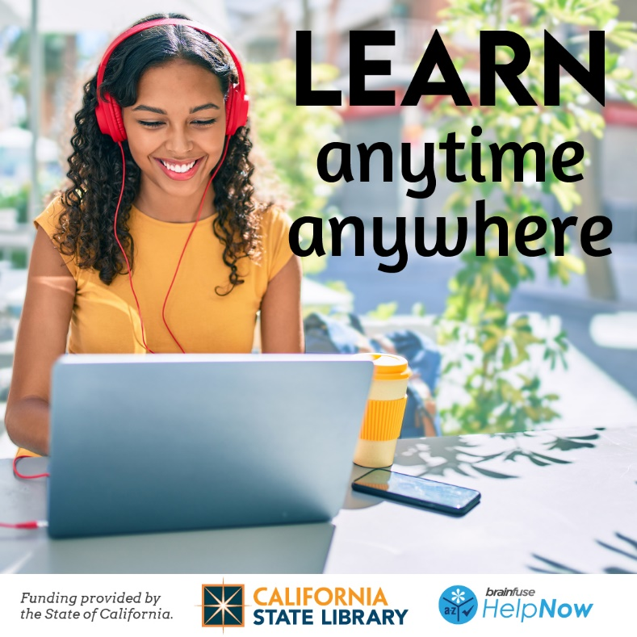

FOR IMMEDIATE RELEASE
Free Online Tutoring Available to All Californians
California State Library provides live, 24/7 online tutoring and homework help in every K-12 subject
[Date], New York, NY – In a major step to provide all Californians with access to equitable learning opportunities, Governor Gavin Newsom announced that every Californian can now receive live, 24/7 online tutoring and homework help in every K-12 subject with Brainfuse HelpNow. Brainfuse has provided supplemental educational services for over twenty years, including online homework help, practice tests, study tools, and collaborative tools.
As part of California’s historic investment in public libraries, all California residents now have access to Brainfuse HelpNow free online tutoring. Students communicate with live tutors using an interactive whiteboard to chat, write, draw, copy/paste text or images, and graph homework problems. Live tutors are available 24 hours a day via any device that connects to the internet. Brainfuse tutors are familiar with California content standards and curriculum frameworks. Brainfuse offers assistance in math, science, language arts, and other core K-12 subjects in English, Spanish, Mandarin, Cantonese, Vietnamese, and Tagalog. There’s no age limit to who can use the service. Adult learners will also have access to writing assistance, citizenship resources, and other skill-building tools.
In addition to live help, there are supplemental tools designed to assist with all aspects of learning. The Writing Lab and the 24/7 Question Center give users the freedom to get assistance any time of day without having to connect with a live tutor. Users can submit papers through the Writing Lab for detailed feedback. The 24/7 Question Center is for non-writing assignments such as math or science questions. Brainfuse HelpNow also offers study and collaborative learning tools.
“Not every family can afford a private tutor. Now through the CA State Library - Brainfuse HelpNow program, every Californian can get free online tutoring. HelpNow tutors will assist all learners from Kindergartners on up build thinking and problem-solving skills. Without giving answers, tutors help students with their homework challenges, and guide them to the right solution,” said Jack Rothstein, Brainfuse Library Services Director.
[Library quote]
This project was supported in whole or in part by funding provided by the State of California, administered by the California State Library.
For the latest information about Brainfuse, contact us at info@brainfuse.com or visit www.brainfuse.com.
About Brainfuse
Brainfuse is one of the nation's leading online tutoring providers, serving a diversified client base of libraries, school districts, and colleges/universities for over two decades. With Brainfuse, users receive real-time tutoring from instructors via our proprietary online classroom. Brainfuse serves hundreds of library systems throughout the country, including the Oklahoma State Library, New Mexico State Library, The State Library of Iowa, New York Public Library, the DC Public Library, Houston Public Library, Toronto Public Library, and North America's largest homework help program through the Chicago Public Library. For more information about Brainfuse services, please contact them at info@brainfuse.com.

About the State Library
Established in 1850, the California State Library is the central reference and research library for state government and the Legislature. The library collection includes more than 4 million titles, 6,000 maps, and 250,000 photographs, and includes an extensive collection of documents from and about the state’s rich history. Around the state, the State Library also serves California’s local libraries, providing more than $500 million state and federal funds to support public libraries and delivering statewide library programs and services. library.ca.gov

